E. Image Zonal Anatomy Segmentation and 3D Model Rendering
MR Segmentation and Modeling
Axial MR PZ, CG, AFS segmentation in ITK-SNAP

MR PZ, CG, AFS modeling in Slicer

3D Rendered PZ,CG,AFS models volumes and tri-axial dimensions measured

Axial MR T2WI images were manually segmented using the smooth polygon tool in ITK-SNAP, using unique labels for the PZ, CG, and AFS. The gland was segmented from base to apex. The base was identified below the bladder, and subsequent images were segmented until the last slice with visible prostatic tissue was identified caudally. The CG, PZ, and AFS were segmented independently according to their well-established anatomical characteristics on T2WI. The PZ was identified by its homogenous high signal intensity on T2WI, which is usually similar to that of the nearby periprostatic fat. The CG was visualized and delineated based on its heterogenous and lower signal intensity as well as its location. Although not readily visible on every case, the AFS was identified by its low T2 signal intensity and its location anterior to the central gland.
The labels for the CG, PZ, and AFS created in ITK-SNAP were then loaded into slicer, and 3D models were rendered for each label. The following parameters in Slicer's model maker tool were used to create these models:
Joint Smoothing | Enabled
Smoothing Algorithim | Laplacian
Laplacian Filter | Yes
Decimation | .1
The 3D models were used to render volume estimates of the PZ and CG, with the sum of PZ and CG representing the total prostate gland volume. AFS volume estimates in select MR cases were included in the total prostate gland volume estimates. Orthogonal tri-axial measurements in the lateral-to-lateral, apex-to-base, and anterior-to-posterior dimensions were made in slicer by placing an ROI cube in the model's center and expanding the ROI cube to fit the maximal model dimensions.

U/S Segmentation and Modeling

Sagittal B-mode Capsule Segmentation in Slicer 4.3

Capsule Modeling in Slicer 4.3

Sagittal ARFI CG Segmentation with Capsule model intersections for guidance in Slicer 4.3

ARFI CG modeling in Slicer 4.3

3d Rendered Capsule and CG models volumes and tri-axial dimensions measured

Sagittal B-mode and ARFI ultrasound image stacks were segmented in Slicer 4.3 using the draweffect tool to model and measure the prostate capsule and CG volume and tri-axial dimensions. The sagittal imaging plane was chosen for segmentation because it has a greater number of easily identifiable anatomical structures: seminal vesicles in the left and right posterior base, urethra in the mid apex, surrounding fibromuscular tissue in the anterior , and rectum in the posterior than either the axial or coronal views. Prostate capsule was segmented in B-mode as this modality offers both high contrast between prostatic tissue and surrounding periprostatic fat, and better SNR in the anterior capsule region than ARFI. ARFI was used to segment central gland as there is clear delineation in this modality between central gland and peripheral zone. This delineation is a result of the greater density of connective tissue within the central gland versus the peripheral zone meaning the central gland is stiffer than the surrounding peripheral zone. Prior to segmentation, both the B-mode and ARFI image stacks were downsampled along the sagittal axis by a factor of 20 i.e. from 360 slices per image stack to 18 slices per image stack. This was done because segmenting 360 slices per image is inordinately time intensive, and does not improve the quality of the 3D rendered model any more than segmenting the more reasonable 18 slices per image stack. The parameters used for the resample scalar volume tool are shown below:

Although, segmentations were performed along the sagittal plane, label map intersections in the axial and coronal views were used during active creation of the sagittal segmentation to further improve segmentation accuracy. This was done by using the resampled image stack, B-mode for capsule and ARFI for CG, as the background in the sagittal plane, and the original image stack as background in the axial and coronal planes. All three orthogonal views were set to the label map assigned to the resampled volume. The B-mode derived capsule was segmented and modeled before the central gland. Parameters used for 3D model rendering were identical to those used in table X for MR modeling. The modeled capsule helprf guide the CG segmentation by enabling capsule model intersections in the three orthogonal planes during CG segmentation. The capsule provided an outer boundary for the CG segmentation. The capsule and CG models were then measured identically to the MR measurement procedure.

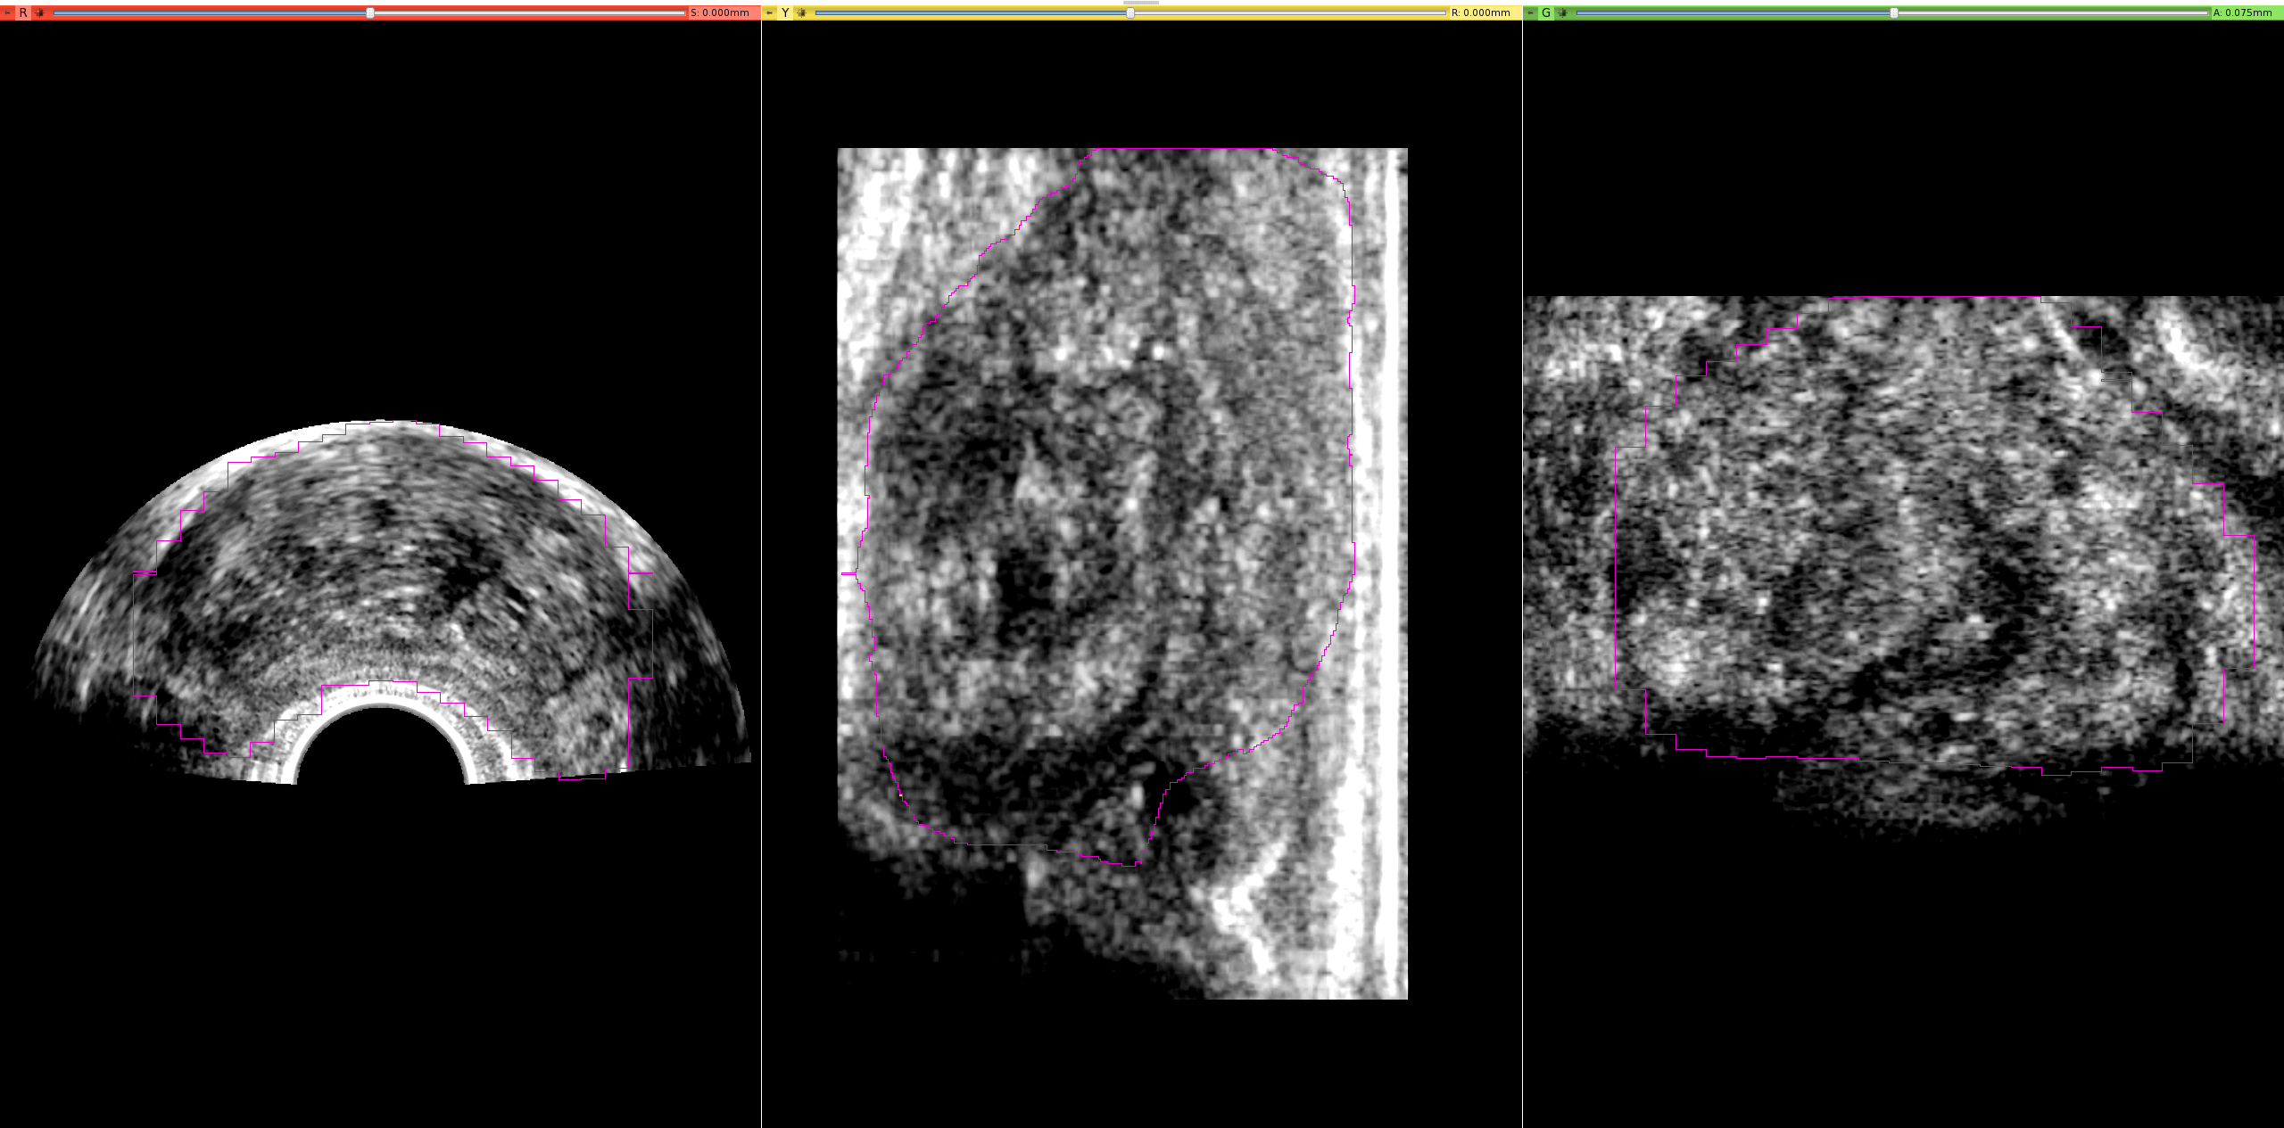
B-mode capsule segmentation [a-f]

Figure x demonstrates B-mode capsule segmentation using all three orthogonal planes. The primary segmentation plane is sagittal (second pane), however the axial (first pane) and coronal (third pane) are used to guide this segmentation because as the label map is built up, the intersections of the label map in the axial and sagittal planes can be viewed as well. The block-like character of the axial/coronal sections of the label map are a direct result of downsampling

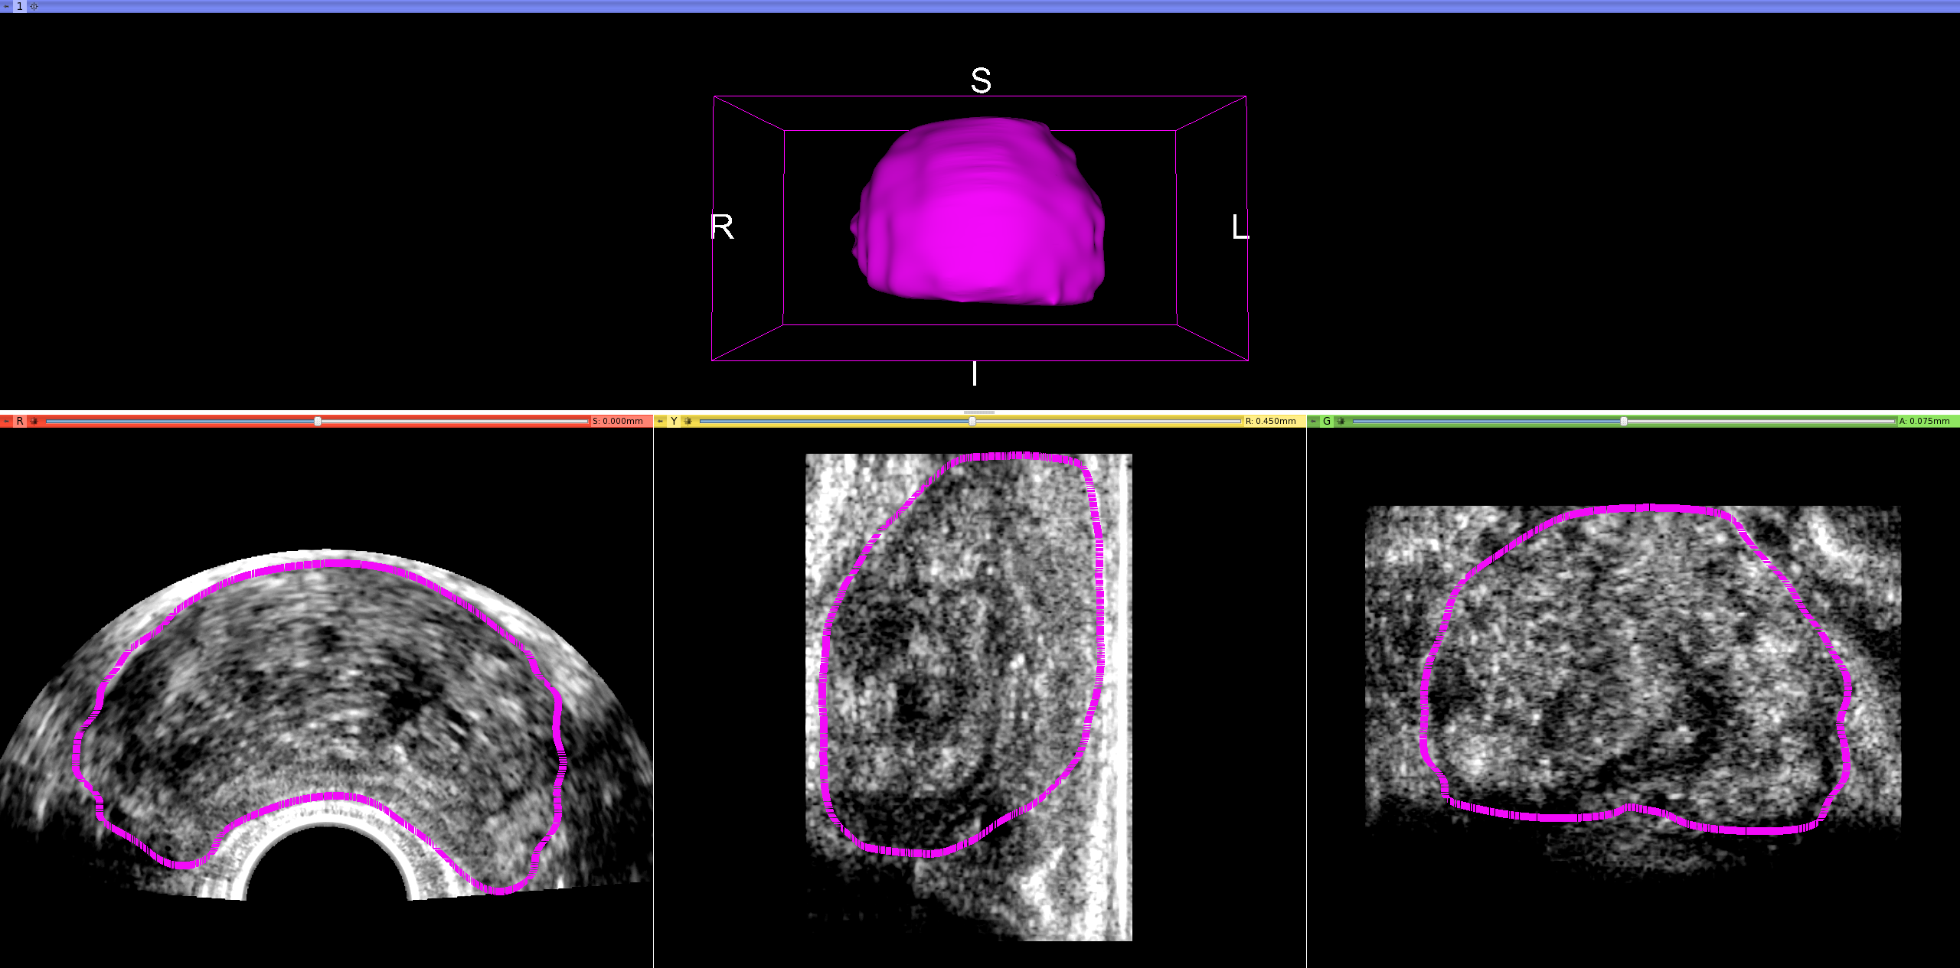

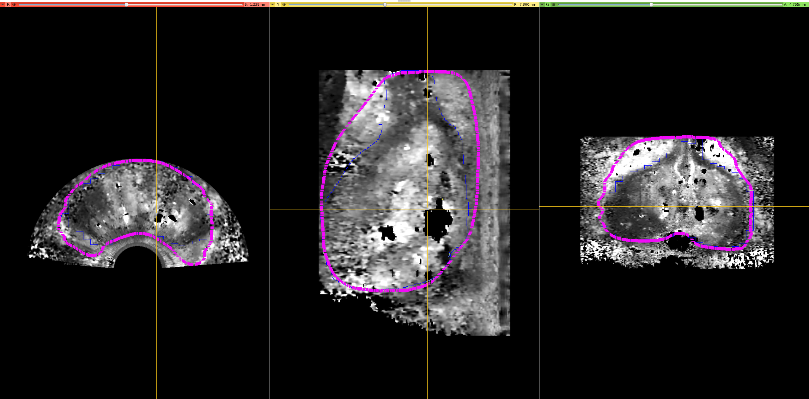
ARFI central gland segmentation [i-k]

Figure x demonstrates the ARFI central gland segmentation (blue) with the capsule model (pink) overlaid for guidance during segmentation

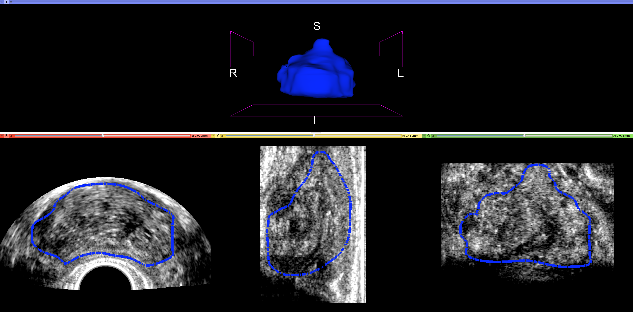
ARFI central gland modeling [k]

Figure x displays the central gland model and model slice intersections created from the central gland label map

Figure x demonstrates the modeled capsule with slice intersections on the axial, sagittal, and coronal planes respectively (all pink). This model was built up from the label map created in the B-mode capsule segmentation

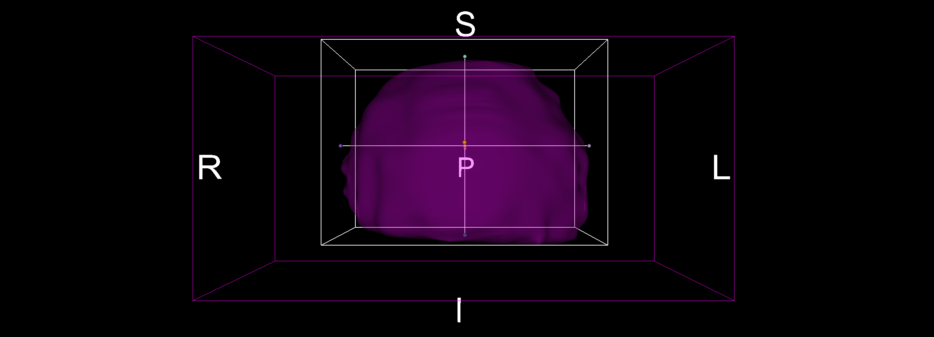
Capsule/Central gland Volume [l-m] and Tri-axial Measurement [n-q]

Figure x displays the ROI tool surrounding the capsule. This ROI tool is used to find the tri-axial dimensions

Motivation

The design of this segmentation procedure was built around three questions:
1. What order should the capsule and central gland be segmented?
2.Which imaging modality: B-mode or ARFI should prostate capsule and central glands be segmented?
3.What is the most effective way to segment capsules/central glands in terms of time and accuracy?

The answers to these three questions are easy to motivate. For question 1, capsule was segmented before central gland. This was done because the capsule defines the outer limit of the central gland's extent suggesting that having capsule model slice intersections turned on while segmenting central gland will improve central gland segmentation accuracy. For question 2, prostate capsule was segmented using the B-mode image stack while central gland was segmented using ARFI. B-mode was chosen for capsule segmentation because B-mode is used clinically to locate the capsule during TRUS biopsies thus it is an established gold standard. Additionally, B-mode provides a higher contrast capsule border in all three imaging planes relative to ARFI. ARFI was used for central gland segmentations because it captures the central gland with much higher resolution than B-mode particularly in the sagittal plane. In order to effectively answer question three, a stepwise series of problems had to be solved in order to maximize segmentation accuracy and minimize segmentation time. The first problem: ultrasound image stacks were finely sampled with approximately 360 slices per image stack. Segmenting at this degree of spatial sampling is incredibly time consuming, and results in diminishing returns in terms of accuracy. The best balance between segmentation time and accuracy was found by down-sampling the image stacks by a factor of 20 i.e. from 360 slices per image to 18 slices per image. The second problem revolved around choice of imaging plane to segment in. After several iterations, the sagittal plane was chosen as the primary segmentation plane for both capsule segmentations in B-mode and central gland segmentations in ARFI as it provides relatively clear delineation of prostatic structures from the surrounding tissues. In addition to the sagittal plane where segmentation was actually performed, the axial and coronal planes were used to further guide and improve segmentation accuracy.

